The Unofficial Recreator 3D

Operations Manual
Designed and built by Joshua R. Taylor
with edits by Brian Alano
- With design contributions from Nick Jones and Ross Conley
- Contributions from Ross Newkirk, Melissa Savides, Yvette and Allen Taylor,
XVICO and Kassie Ma
Thank you to everyone who made The Recreator 3D possible!

RECREATOR3D.COM - RECYCLE.XYZ - JRT3D.COM - 2021 https://www.facebook.com/groups/recreator3d
Inspired by The Online DIY PET Pultrusion Community and
The Need of Recycling Properly for our Future Production Needs!
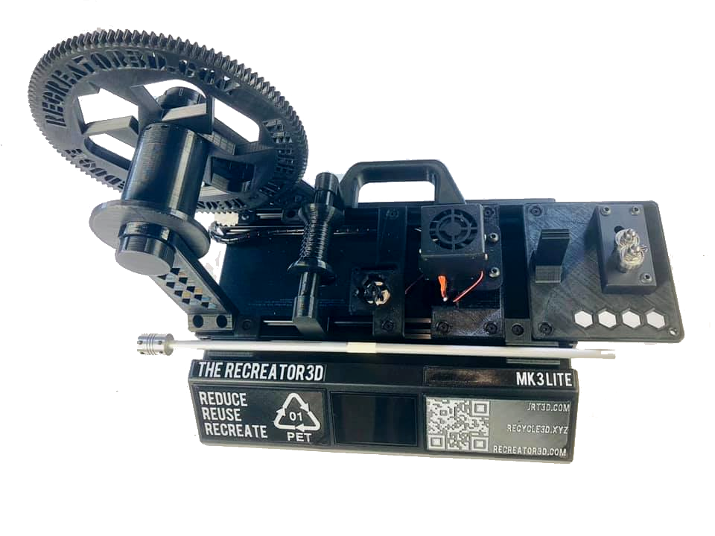

General Information Before Starting
The MK3Lite uses a single motor. The MK3Pro uses dual motors and is suggested for industrial graded or experimental plastics beyond soda bottles.
Both can pull at 400 to 600 mm/min. 400 mm/min and hot end temperatures between 195 and 200 °C is recommended. 200 °C is required for the printer to run the G-code commands.
Going above 600 mm/min with temperatures higher than 210 are not recommended as degradation in the filament quality is likely.
The Spooling command is long enough for a 2L bottle. You will see the strip getting smaller towards the neck of the soda bottle and this is a good time to cut the bottle from the pull. Cut toward the back of the unit and let the puller continue the pull. Be very careful at this point. The will tend to whip around in a circle when exiting the nozzle and can catch your face or eyes if you are close enough to the unit. Use of safety glasses is recommended for this step as well keeping your face away from your unit while unloading the bottle and filament from the spooling process.
When pulling the filament through the nozzle manually, if there is a lot of resistance likely the strip is cut too wide for its thickness. There should be some force needed to pull the filament but it shouldn't be a struggle either.
If the bottle is making a rough sandpaper textured filament, the pull speed may be excessive. Reduce the speed or use the bottle cutter guide and twist the filament, placing the guide into its locking slot. This should help add some tension in the pull and relieve this roughness.
If you experience skipping or binding during the pull, the bottle wall may be thicker than expected. Verify the thickness of your bottle or just reduce the width to the next lower size and this should allow for better pulling. For example if a bottle is 0.30 mm thick it can be cut at an 8 mm width. This should be able to be pulled at 600mm.
If these do not correct the problem, reduce the pull speed to the next lower speed. Also make sure your spool rod nuts are not fully locked. A little loose is better than super tight.
Standard 2L soda bottles work especially well, letting the Recreator 3D do the pulling for you. Not all #1 PET bottles will work so experimenting is crucial. Please submit your findings to the master index of easily converted plastics. The unit can also be used to manually pull PET strips through the cutter, and then load the strips directly into the pultruder without passing again through the cutter.

Preparing for Extrusion
1. Clean and wash your bottle of all labels and glue. The bottles must be fully clean and dry from water and other cleaning solutions. To remove labels, soak the bottles in hot water, and peel them off. Don’t use a knife to cut the labels, as this may damage your bottles. Apply vegetable oil or Goo Gone to the glue. Scrub it off and wash with soapy water. Rinse thoroughly with water and dry.
2. To smooth out the bottle, use a heat gun and a drill. Connect the bottle to the drill (using a bolt attached to its cap) and rotate it over a heat gun to smooth out any ruffles or bumps in the bottle. This step is optional and mainly done to get a few extra inches of material from the bottle.
3. Cut the bottom of the bottle off and cut off a small strip. Use calipers to measure the thickness of the strip. Refer to the “Bottle Thickness to Cut Width” conversion chart to determine the correct cut width for the thickness. Adjust the cutter to the specified width. Group your bottles together by brand and type to avoid needing to change the cutter's thickness constantly.
Bottle Thickness to Cut Width Conversion Chart
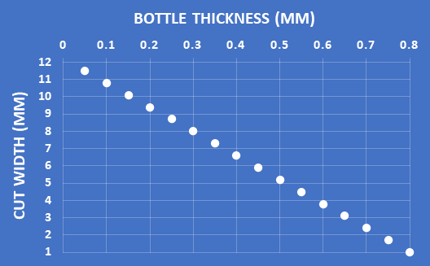

Bottle thickness 0,20 mm --- width 10 mm --- Filament diameter 1.6
Bottle thickness 0,25 mm --- width 09 mm --- Filament diameter 1.6
Bottle thickness 0,30 mm --- width 08 mm --- Filament diameter 1.6
Bottle thickness 0,35 mm --- width 07 mm --- Filament diameter 1.6
Bottle thickness 0,40 mm --- width 06 mm --- Filament diameter 1.6
Bottle thickness 0,45 mm --- width 05 mm --- Filament diameter 1.6

Operating The Recreator 3D
1. Insert the Bottle Rod into the Cutter Base. Drop the bottle onto the rod and start to rotate the bottle through the cutter to start the strip. Make sure the bottle is sitting on top of the bearing. Attach the bottle weight to the top and attach the keyfob tensioner from the weight to the base of the cutter. Pull about 10 inches to work with.
2. Power on the Unit. Cut the strip into a thread, about 1/16th of a 2 inch length. This will be threaded through the 1.60mm nozzle. Make sure to give this a little tension while the nozzle is cold. Insert the thin, cut end of the strip into the heater block. Keep the end centered in the hole so that it can fit through the nozzle on the opposite end. Once it’s through nozzle, use pliers to grab the end of the plastic. DO NOT use your hands to pull the filament. It’s very easy to harm yourself doing this.
3. Continue to grip the ribbon on the nozzle side. Set the heat to 200 °C, and wait before proceeding. Be mindful that as the temperature rises the strip will deform and it can pull itself backwards. Slowly start to pull the filament forward as the temperature reaches 140 °C. At 180 °C the filament should start to easily be pulled through the nozzle. 190 °C is the suggested lowest processing temperature. Bring the temperature to 200 °C, as the unit won't run until below 200 °C.
4. Once fully heated, attempt to pull the filament through the heating block with the pliers. This may take a bit of force. If you find that you are exerting a lot of force in order to do this, you may need to wait for it to heat up a while longer or double check your bottle’s cut width.
5. Continue to pull the filament with the pliers in an even, smooth motion until you have approximately 14 inches of filament extruded. You can either noose your filament with a draw string or continue to pull enough to noose into the spooler. Lock the filament into place with a spacer that is either printed or taken from your wheels.
6. Once this is done, start up the stepper motor. Slowly move the spooler to the right to initially tension the filament onto the spool. On your SD Card should be your Travel Commands. Based on your bottle loaded, determine what speed is best and load that G-code command. Run the 400mm G-code from the SD Card to start the Pultrusion Process. This is the standard suggested speed for both MK3Lite and MK3Pro.
7. Continue until the whole strip has been extruded. Running the G-code should finish a 2L bottle. At the end, the filament may spring forward, and around the spool, so it is best to stay back from the machine until it is completely stopped. Consider wearing safety glasses for the end step.
8. Turn the temperature to 0 or power down the unit, and untie your filament from the spool. You will have to manually remove and spool up your filament.
9. The process is complete! Your filament is ready to use.

Preparing Your Printer To work With the Pultruded Filament
We’ve included this to easily guide you along in your first time use of this experimental filament.
This filament is actually similar to a straw, with a hollow inside. The outer diameter is formed through the nozzle (any size can be drilled, ours is around 1.60mm). With the expansion of this material as it exits the nozzle, as well the nature of it being hollow, this diameter is approximate. We’ve seen numbers between 1.58 and 1.66 mm.
With this in mind we’ve found increasing our favorite slicer’s flow rate to 150% has allowed us to accommodate this variance.
Please use the filament wisely. We suggest smaller amounts be used for your initial calibrations. Once you’re happy with your settings try the larger amounts.
We’ve found that this filament needs to have part cooling enabled. With no cooling the filament can transition to “glass” causing some oozing.
If you find your filament is not properly bonding you can increase your flow rates within your slicer. We’ve found using the following slicer settings has allowed us to print successfully. If you find this not to be the case, please reach out to us via our Facebook group account.
We’d also love to know about what settings worked for you and what you printed, please join the group and share your finished prints!
Filament from Soda Bottles Suggested Slicer Settings Using CURA 4.8
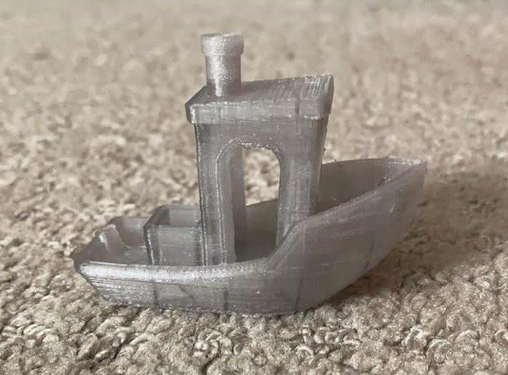
and Ender 3 Clone with Direct Drive and Dual Parts Cooling:
- Layer Height...............0.2mm
- Nozzle Temp..............255
- Bed Temp...................75
- Flow...........................150%
- Initial Layer Flow.......160%
- Print Speed ...............30%
- Fan.............................20%
- Retraction..................4.5mm
- Retraction Speed…....40
3DBenchy - The jolly 3D printing torture-test by CreativeTools.se
- Printed with Coca Cola Soda PET Bottle on a Ender 3 Clone with Direct Drive.
STL: https://www.thingiverse.com/thing:763622

